**CoCo Keys2USB v1.2**

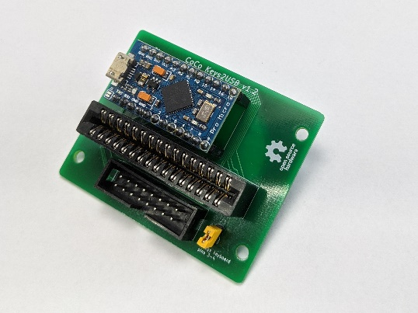

Thank you for your interest and purchase of the CoCo Keys2USB keyboard encoder, for use with a TRS-80 Color Computer keyboard.

Please take a moment to review the package contents to ensure all the items you ordered were included. If you ordered a kit, there should be an accompanying checklist of all items that are part of a kit order – please look to make sure all parts were included. If you are missing any items, please contact me at [WynDecSystems@gmail.com](mailto:WynDecSystems@gmail.com).

**Kit Assembly**

* Assemble the ATMega32U4 microcontroller by soldering the (2) 1x12 headers (included in mylar bag with the microcontroller) to the microcontroller board. If you have a breadboard handy, positioning the headers in the breadboard and placing the microcontroller on the pins, makes this an easier task.
* Solder the connectors, microcontroller headers, and jumper header to the up-side (indicated by the white silkscreen CoCo Keys2USB v1.2 label) of the PCB. The orientation of the 2x8 IDC header is the only connector that requires attention – the silkscreen outline indicates the notched polarity marking.
* When installing the microcontroller headers on the PCB, it is easiest to slide the headers on to the microcontroller pins to both stabilize for soldering and use as ‘heat sink’ to prevent any melting of the headers. There is a ‘USB’ marking on the microcontroller silkscreen, indicating orientation of the USB connector end.
* If you decide to use your own header or flat-flex connector, pay attention to the pin-1 markings where the 2x16 card edge connector would normally be installed. There are two of these markings, which allow for two different orientations.
* The ATMega32U4 should come already programmed with a copy of the keyboard encoder firmware. The latest firmware may be obtained at <https://github.com/wyndec/CoCoKeys2USB>.

**Instructions**

* For standard TRS-80 keyboards, slide the 16-pin keyboard flat-flex, mylar cable into the 2x16-pin card edge connector – the orientation doesn’t matter since the connector is wired for either direction. In most cases, the flat-flex cable will be a little loose – there is an included nylon shim that can be used on the backside or underside of keyboard cable, to keep it tightly in the card-edge connector.
* Plug in the keyboard encoder with your own USB-micro to USB-A cable – your operating system should detect the encoder as a HID Keyboard device.
* There are (3) pre-programmed key maps on the device, pressing Shift+F2 (or Shift+Enter for non-CoCo3 keyboard) will switch between the three key maps. You can tell which key map is selected as a ‘V’, ‘X’, or ‘M’ will display on the screen – indicating ‘VCC’, ‘XRoar’, and ‘MAME’ respectively. Other key-combinations include Ctrl+T for ‘Tab’, Ctrl+’@’ for ‘@’ symbol, Ctrl+’Left-Arrow’ for destructive backspace, and Alt+F1/Alt+F2 for switching between consoles on a CoCoPi3 setup.
* The firmware is user-programmable, using the standard Arduino IDE. A copy of the latest firmware may be downloaded at <https://github.com/wyndec/CoCoKeys2USB>
* There is an optional 2x8 IDC header connector which is future support for the direct connection of Ed Snider’s CoCo MECH Keyboard ribbon cable. The CoCo MECH keyboard comes with an adapter crimped on the ribbon cable – this allows for connection to the 2x16-pin card-edge connector. However, it’s possible to crimp a 2x8 female IDC connector to the ribbon cable to plug directly into the 2x8 IDC header on the keyboard encoder. If you decide to do this, please proceed with caution as you may damage your CoCo MECH keyboard. Current versions of Ed’s CoCo MECH keyboard will require the jumper to be installed on **J3** of the keyboard encoder, bridging pins 3-4 of the keyboard – otherwise, the jumper is not needed.
* Please make sure to secure your keyboard and CoCo Keys2USB keyboard encoder to a firm mounting location. The flat-flex, mylar cable of the Color Computer keyboard is extremely fragile and easily damaged if not secured properly. The optional mounting block is a great option to secure the keyboard encoder inside a Color Computer case, without the need to drill holes through the case.

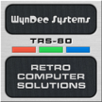

***WynDec Systems – Retro Computer Solutions***